COURSE: CLOUD AND NETWORK SECURITY _C1-2024
STUDENT NAME: LENNIE NTHIGA
STUDENT NO: cs-cns07-24170
November 14,2024

WEEK 8 ASSIGNMENT 2
Assignment 2: Network Security Groups and Application Security Groups

Introduction
In the attentivity we would be configuring the network security group and the application security groups
Network security group are rules that are used to filter and monitor network traffic between Azure resources in an Azure virtual network. This group is used to give policies and rules to the virtual networks on inbound network traffic to, or outbound network traffic from, several types of Azure resources.
Application security groups` allows one to group virtual machines and define network security policies based on those groups this enables the handling f security policy scalable without manual maintenance e.g.
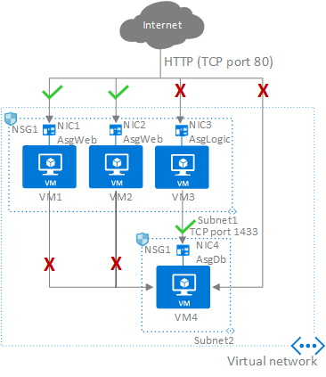

structure of the lab
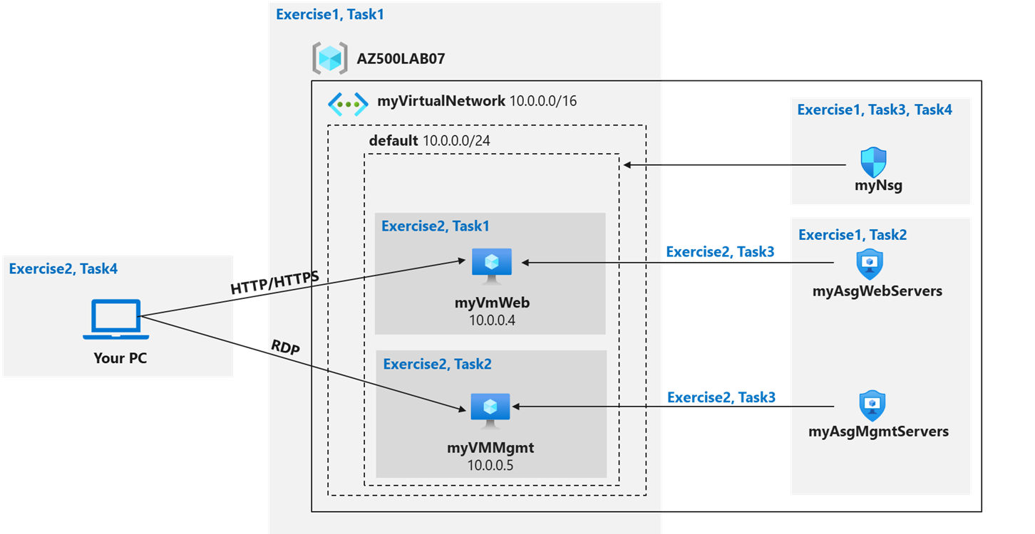

Step 1: Create the virtual networking infrastructure

Task 1: Create a virtual network
We created a virtual network myvirtualnetwork in resource group AZ500LAB07 with subnet 10.0.0.0/24
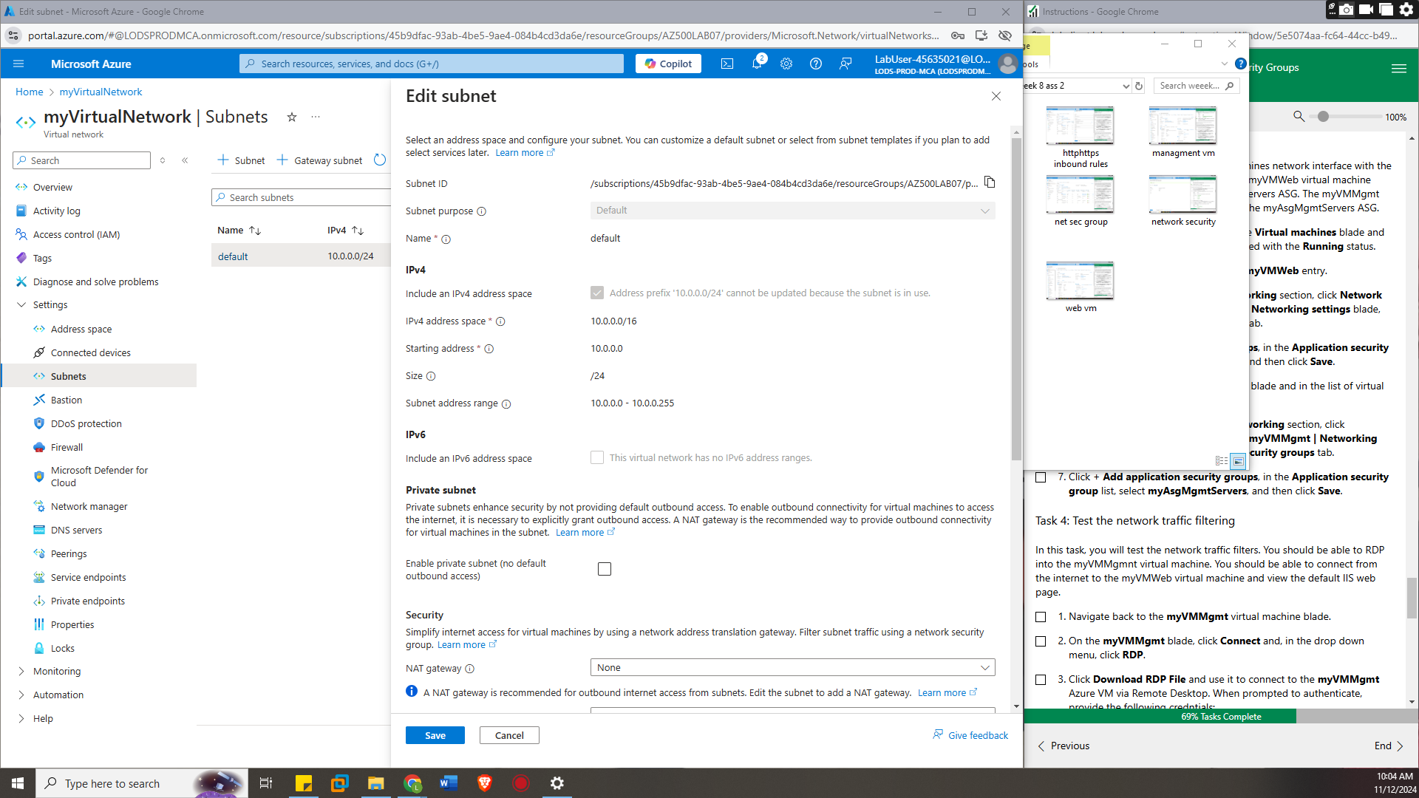

Task 2: Create application security groups
Searching for application security groups on the search bar create one under the resources group with the name myAsgWebServers for the web with HTTP and HTTPS protocols permitted and another myAsgMgmtServers with the RDP protocol permitted 3389 used for management purposes
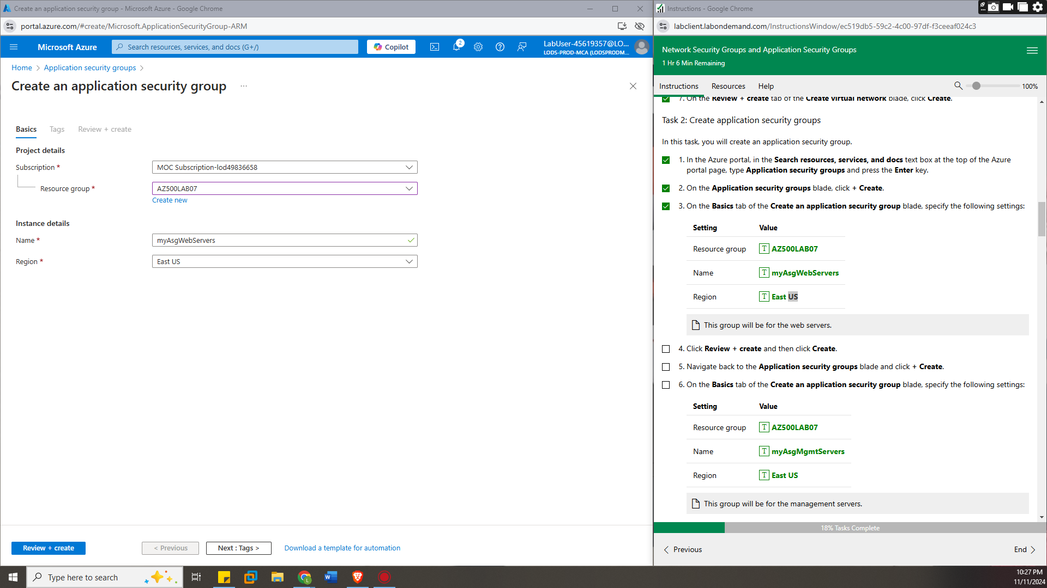

Task 3: Create a network security group and associate the NSG to the subnet
Creation of a network security group under the name myNsg
Associating the virtual networks subnet default to the network security group myNsg

Task 4: Create inbound NSG security rules to all traffic to web servers and RDP to the servers.
We would create rules to inbound traffic to the myasgwebservers of the application security to allow traffic through pot 80 and 443 under TCP protocol with priority 100 this being a webserver
And inbound rule for myAsgMgmtServers application security group to allow traffic through port 3389 with priority 110 which is high
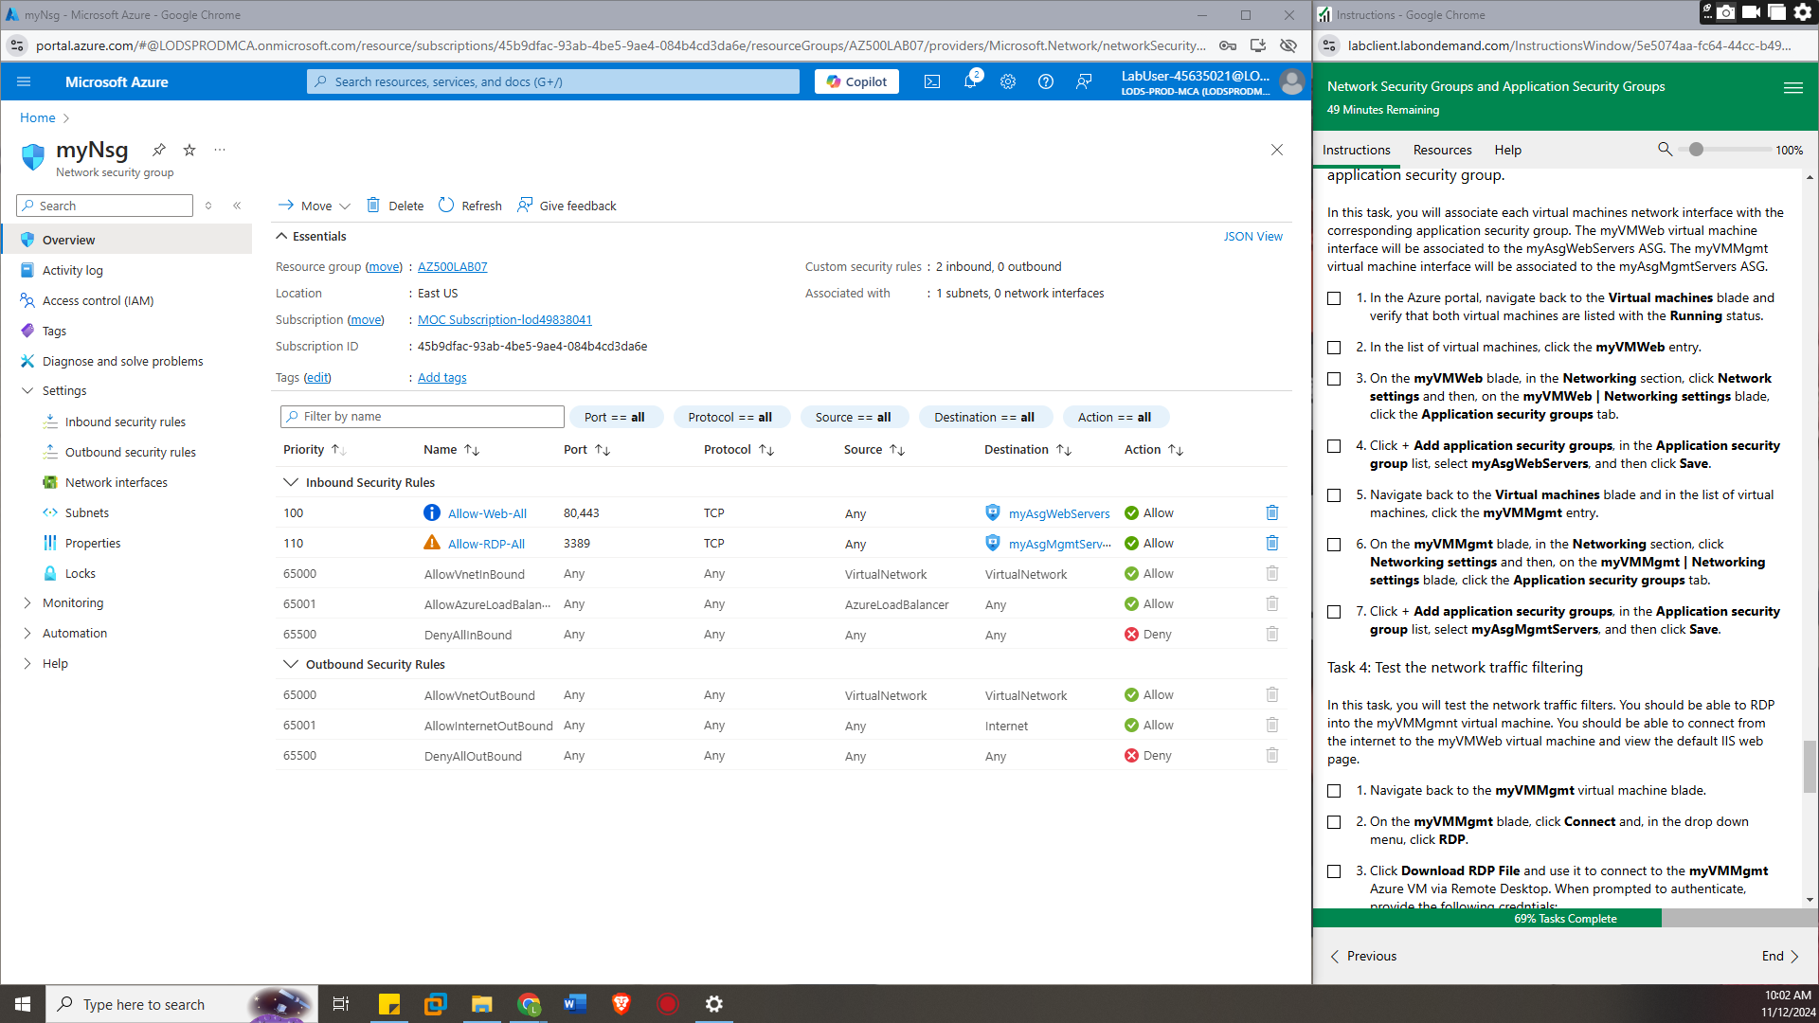

step 2: Deploy virtual machines and test network filters

Task 1: Create a virtual machine to use as a web server.
Create a virtual machine name myVmWeb with an image an image of Windows Server 2022 Datacentre: Azure Edition- x64 Gen2 and size of Standard D2s v3 of which the OS disk type would be a standard HDD
And a 2nd one for myVmMng with similar configurations below is for myVmMng
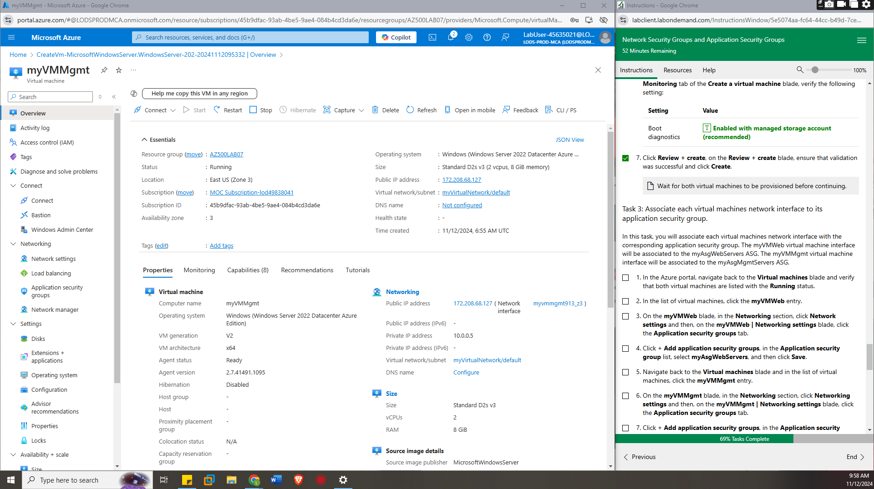

Task 3: Associate each virtual machines network interface to its application security group.
In virtual machines resources under the myVMWeb machine in networking settings click application security groups and pick the myAsgWebServers so as to link the application security for web to the virtual machine of web
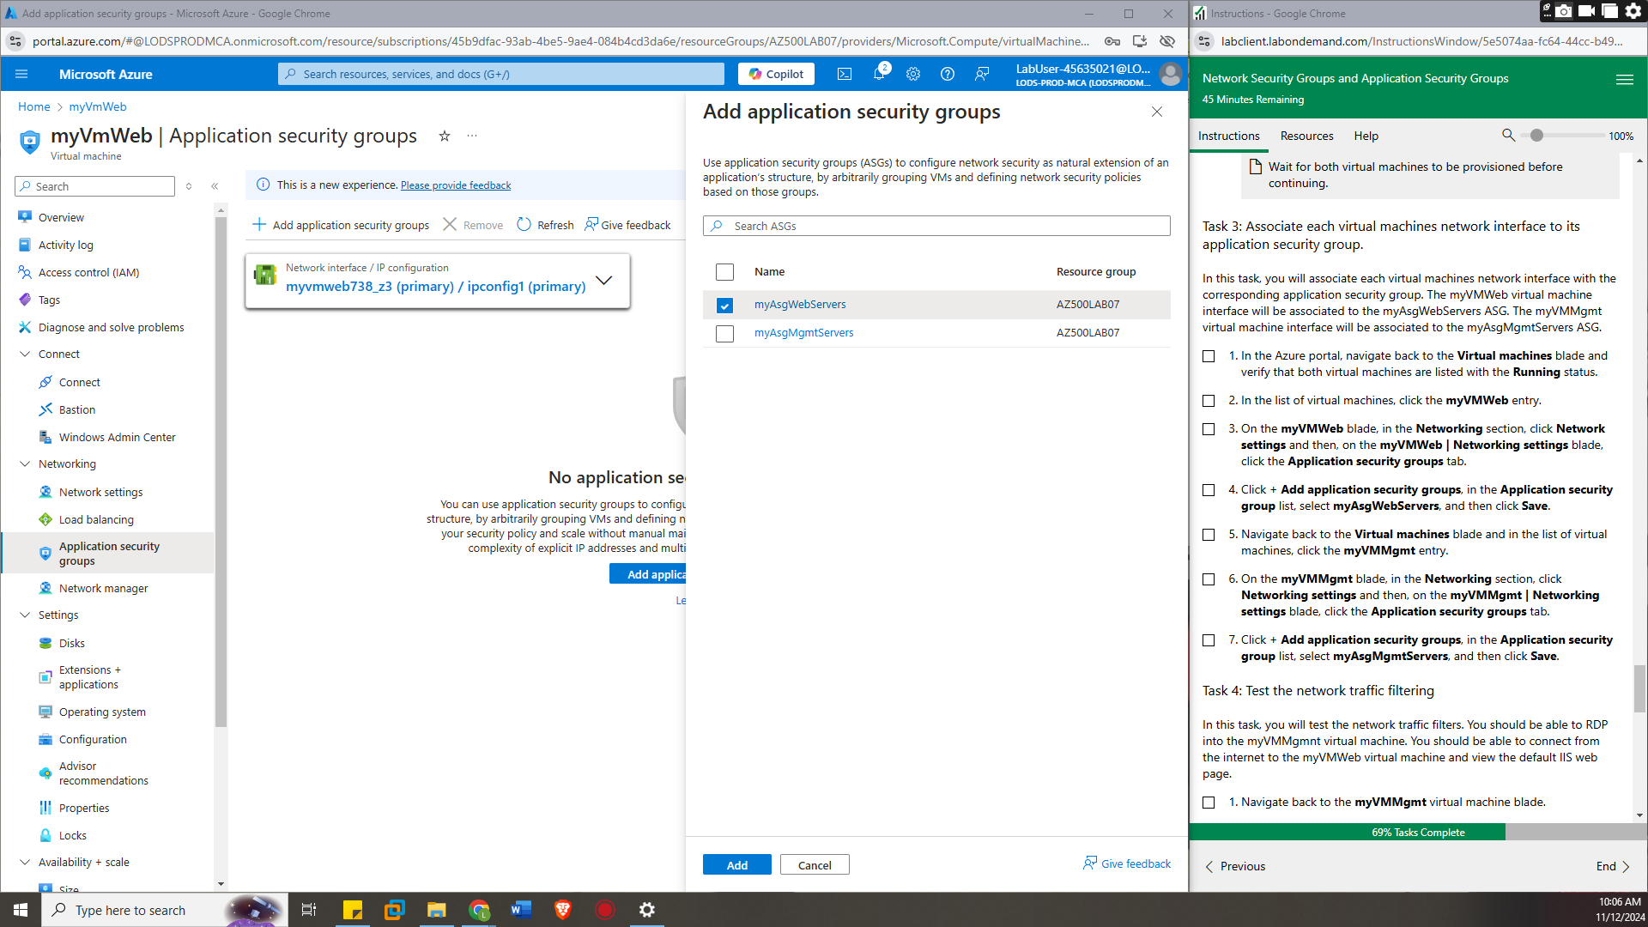
and same case for myVMMgmt machine which would be linked to myAsgMgmtServers
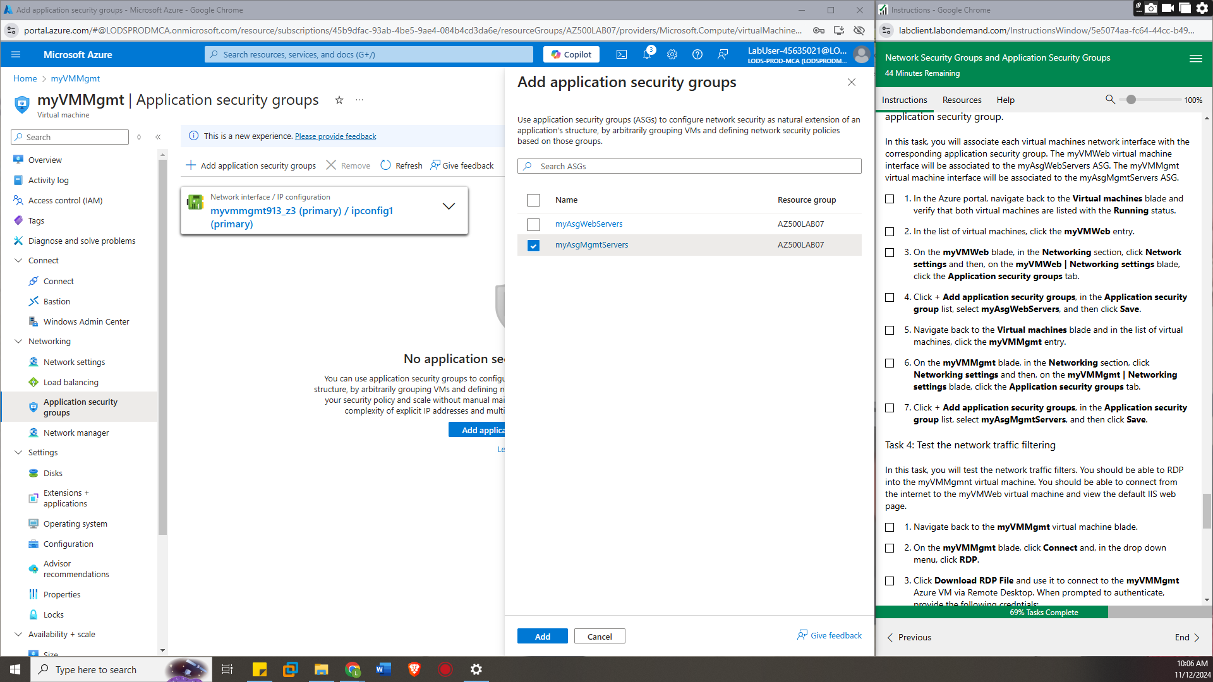

Task 4: Test the network traffic filtering
We would download the prepared RDP file to un which would promote for a password which would rant access to the myVMMgmt machine
We would run Install-WindowsFeature -name Web-Server -IncludeManagementTools in PowerShell to give the myVMWeb a webserver role
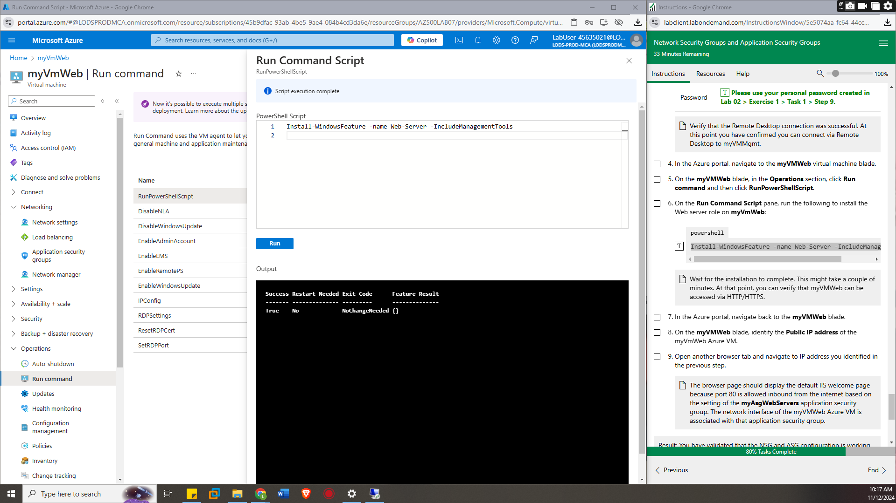
Identify the public Ip address of the myVMWeb machine search it in the browser inside myVMMgmt machine which would post the ibis website
As shown
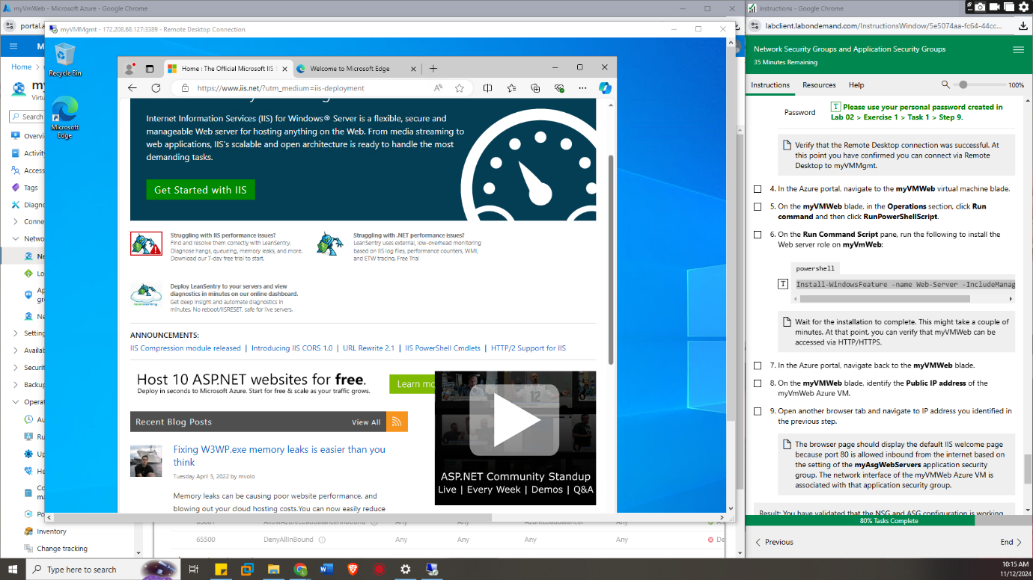

Conclusion
I found that its possible to have a virtual machine which acts as a web server by allocating it rules for that role while another virtual machine being a remote machine that can be used by a user. I believe by having grouping we can have multiple virtual machines in a group given the same rules such as for webserver HTTP and HTTPS access which can help in reducing overload when users are accessing it .thus controlling traffic

